**MySQL JOINS - Exercises, Practice, Solution**

1. Write a [MySQL](https://www.w3resource.com/mysql-exercises/join-exercises/) query to find the addresses (location_id, street_address, city, state_province, country_name) of all the departments.  
   Hint : Use NATURAL JOIN.

[SELECT](http://localhost/phpmyadmin/url.php?url=https://dev.mysql.com/doc/refman/8.0/en/select.html) LOCATION_ID,STREET_ADDRESS,city,STATE_PROVINCE,COUNTRY_NAME FROM locations NATURAL JOIN countries;

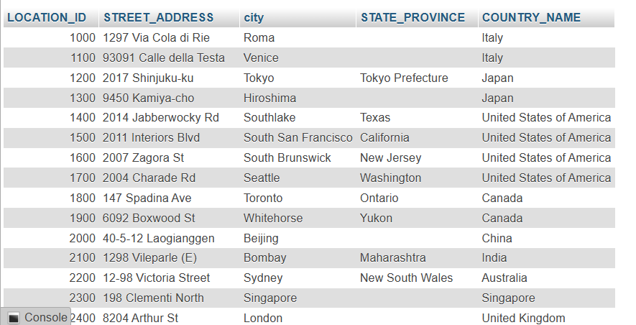

1. Write a MySQL query to find the name (first_name, last name), department ID and name of all the employees.

[SELECT](http://localhost/phpmyadmin/url.php?url=https://dev.mysql.com/doc/refman/8.0/en/select.html) FIRST_NAME,LAST_NAME,DEPARTMENT_ID,DEPARTMENT_NAME FROM employees JOIN departments USING (DEPARTMENT_ID);

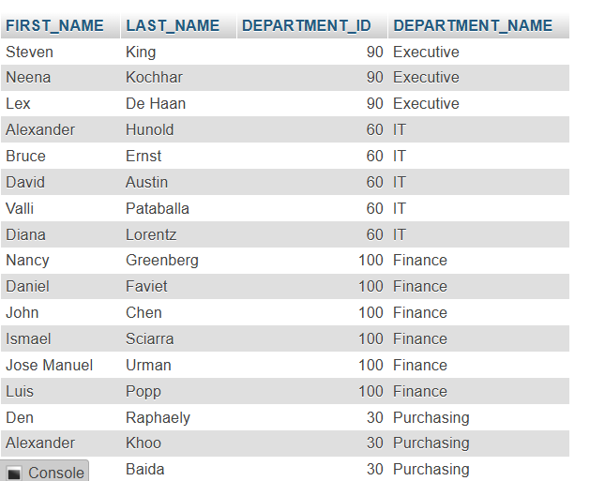

1. Write a [MySQL](https://www.w3resource.com/mysql-exercises/join-exercises/) query to find the name (first_name, last_name), job, department ID and name of the employees who works in London.

[SELECT](http://localhost/phpmyadmin/url.php?url=https://dev.mysql.com/doc/refman/8.0/en/select.html) e.FIRST_NAME, e.LAST_NAME, e.JOB_ID, e.DEPARTMENT_ID, d.DEPARTMENT_NAME FROM employees e JOIN departments d ON (e.DEPARTMENT_ID = d.DEPARTMENT_ID) JOIN locations l ON (d.LOCATION_ID = l.LOCATION_ID) WHERE LOWER(l.CITY) = 'London';



1. Write a [MySQL](https://www.w3resource.com/mysql-exercises/join-exercises/) query to find the employee id, name (last_name) along with their manager_id and name (last_name).

[SELECT](http://localhost/phpmyadmin/url.php?url=https://dev.mysql.com/doc/refman/8.0/en/select.html) e.EMPLOYEE_ID 'Emp_Id', e.LAST_NAME 'Employee', m.EMPLOYEE_ID 'Mgr_Id', m.LAST_NAME 'Manager' FROM employees e JOIN employees m ON (e.MANAGER_ID = m.EMPLOYEE_ID);

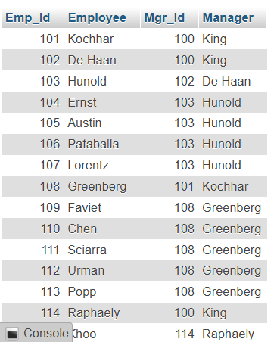

1. Write a [MySQL](https://www.w3resource.com/mysql-exercises/join-exercises/) query to find the name (first_name, last_name) and hire date of the employees who was hired after 'Jones'.

[SELECT](http://localhost/phpmyadmin/url.php?url=https://dev.mysql.com/doc/refman/8.0/en/select.html) e.FIRST_NAME, e.LAST_NAME, e.HIRE_DATE FROM employees e JOIN employees davies ON (davies.LAST_NAME = 'Jones') WHERE davies.HIRE_DATE < e.HIRE_DATE;

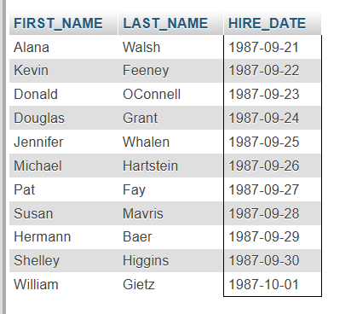

1. Write a [MySQL](https://www.w3resource.com/mysql-exercises/join-exercises/) query to get the department name and number of employees in the department.

[SELECT](http://localhost/phpmyadmin/url.php?url=https://dev.mysql.com/doc/refman/8.0/en/select.html) DEPARTMENT_NAME AS 'Department Name', [COUNT](http://localhost/phpmyadmin/url.php?url=https://dev.mysql.com/doc/refman/8.0/en/aggregate-functions.html%23function_count)(*) AS 'No of Employees' FROM departments INNER JOIN employees ON employees.DEPARTMENT_ID = departments.DEPARTMENT_ID GROUP BY departments.DEPARTMENT_ID, DEPARTMENT_NAME ORDER BY DEPARTMENT_NAME;

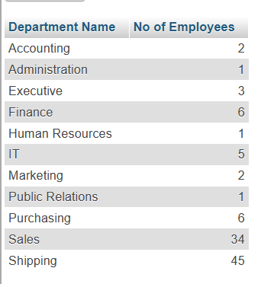

1. Write a [MySQL](https://www.w3resource.com/mysql-exercises/join-exercises/) query to find the employee ID, job title, number of days between ending date and starting date for all jobs in department 90.

[SELECT](http://localhost/phpmyadmin/url.php?url=https://dev.mysql.com/doc/refman/8.0/en/select.html) EMPLOYEE_ID, JOB_TITLE, END_DATE - START_DATE AS Days FROM job_history NATURAL JOIN jobs WHERE DEPARTMENT_ID = 90;

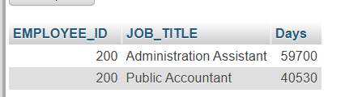

1. Write a [MySQL](https://www.w3resource.com/mysql-exercises/join-exercises/) query to display the department ID and name and first name of manager.

[SELECT](http://localhost/phpmyadmin/url.php?url=https://dev.mysql.com/doc/refman/8.0/en/select.html) d.DEPARTMENT_ID, d.DEPARTMENT_NAME, d.MANAGER_ID, e.FIRST_NAME FROM departments d INNER JOIN employees e ON (d.MANAGER_ID = e.EMPLOYEE_ID);

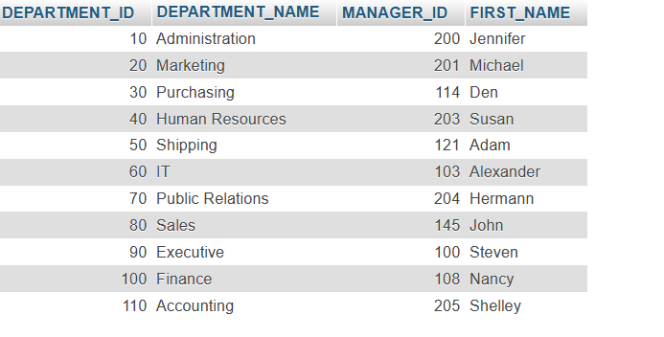

1. Write a [MySQL](https://www.w3resource.com/mysql-exercises/join-exercises/) query to display the department name, manager name, and city.

[SELECT](http://localhost/phpmyadmin/url.php?url=https://dev.mysql.com/doc/refman/8.0/en/select.html) d.DEPARTMENT_NAME, e.FIRST_NAME, l.CITY FROM departments d JOIN employees e ON (d.MANAGER_ID = e.EMPLOYEE_ID) JOIN locations l USING (LOCATION_ID);

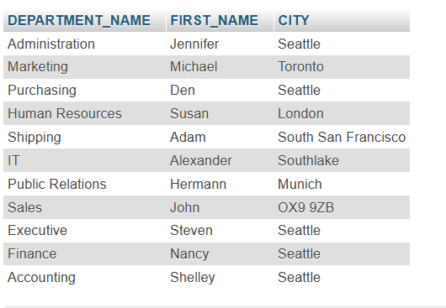

1. Write a MySQL query to display the job title and average salary of employees.

[SELECT](http://localhost/phpmyadmin/url.php?url=https://dev.mysql.com/doc/refman/8.0/en/select.html) [AVG](http://localhost/phpmyadmin/url.php?url=https://dev.mysql.com/doc/refman/8.0/en/aggregate-functions.html%23function_avg)(SALARY),JOB_TITLE FROM employees NATURAL JOIN jobs GROUP BY JOB_TITLE;

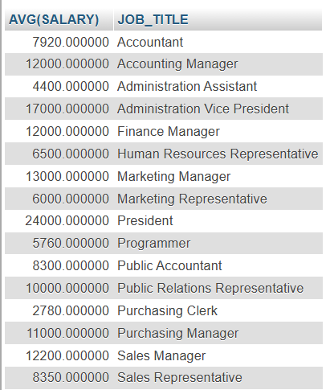

1. Write a MySQL query to display job title, employee name, and the difference between salary of the employee and minimum salary for the job.

[SELECT](http://localhost/phpmyadmin/url.php?url=https://dev.mysql.com/doc/refman/8.0/en/select.html) FIRST_NAME,JOB_TITLE,SALARY-MIN_SALARY FROM employees NATURAL JOIN jobs;

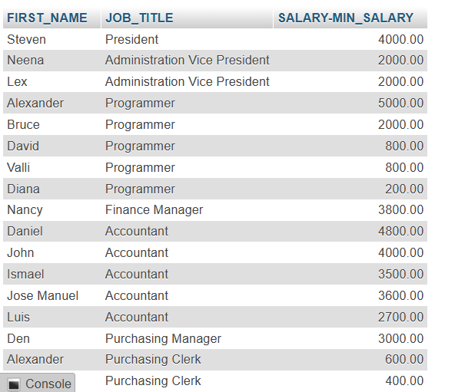

1. Write a MySQL query to display the job history that were done by any employee who is currently drawing more than 10000 of salary.

[SELECT](http://localhost/phpmyadmin/url.php?url=https://dev.mysql.com/doc/refman/8.0/en/select.html) jh.* ,e.SALARY FROM job_history jh JOIN employees e ON (jh.EMPLOYEE_ID = e.EMPLOYEE_ID) WHERE SALARY > 10000;

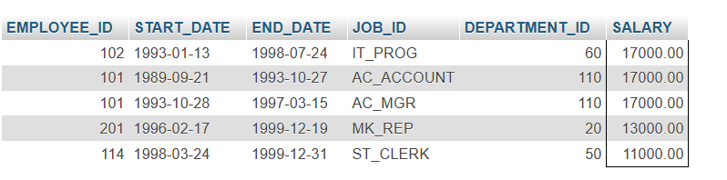

1. Write a MySQL query to display department name, name (first_name, last_name), hire date, salary of the manager for all managers whose experience is more than 15 years.

[SELECT](http://localhost/phpmyadmin/url.php?url=https://dev.mysql.com/doc/refman/8.0/en/select.html) FIRST_NAME, LAST_NAME, HIRE_DATE, SALARY, (DATEDIFF(now(), HIRE_DATE))/365 Experience FROM departments d JOIN employees e ON (d.MANAGER_ID = e.EMPLOYEE_ID) WHERE (DATEDIFF(now(), HIRE_DATE))/365 > 15;

